>>>>>>>REPORT FOR EXPERIMENT(2)<<<<<<

1:EXPERIMENT NAME:JUDGMENT OF RELATION PROPERTIES.

2:COMPILER NAME:DEV C++(WHICH SUPPORT C++11)

#IF YOUR COMPILER DON’T SUPPORT C++11 FOLLOW MY GIVING RULE AND MAKE YOUR COMPILER FOR SUPPORT C++11

#GO TOOLS MENU THEN GO COMPILER OPTIONS AFTER SELECT GENERAL THEN TYPE -std=c++11 THEN CLICK (OK)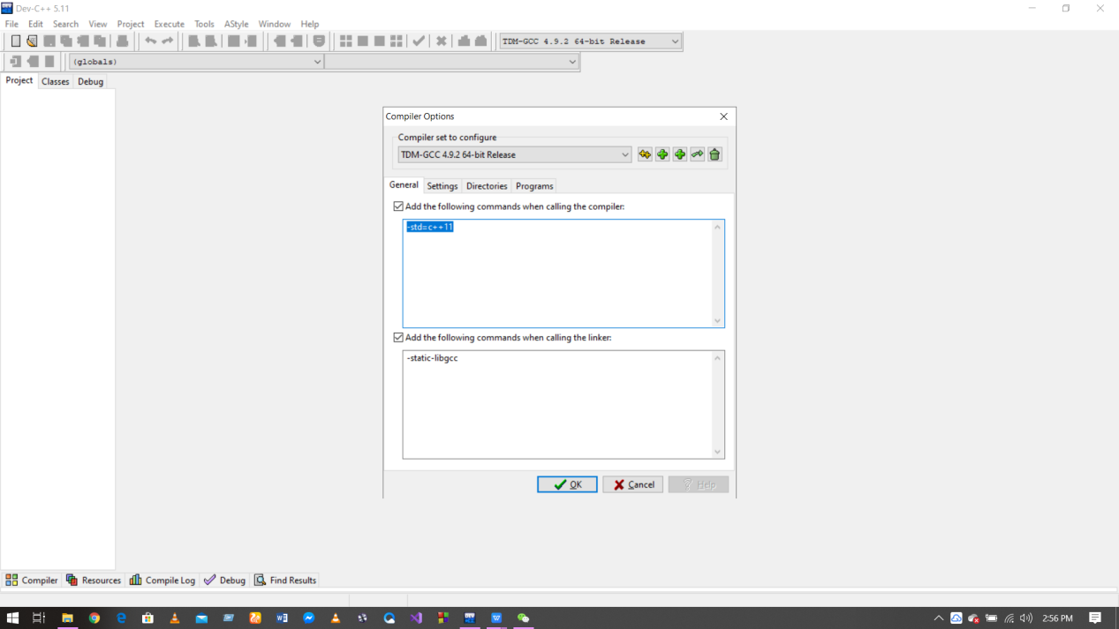

3: PROGRAMMING DEGINE:C++

4:RUNNING RESULT AFTER INPUT: 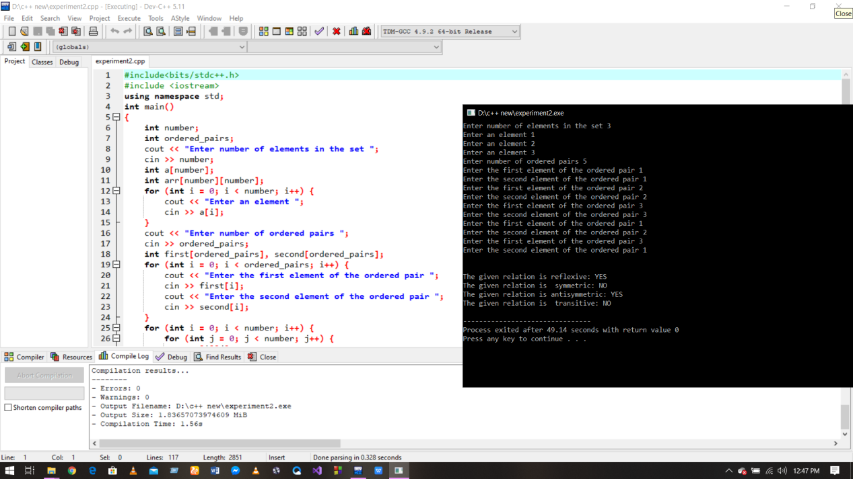

#The given relation is reflexive: YES

#The given relation is symmetric: NO

#The given relation is anti symmetric: YES

#The given relation is transitive: NO

5:COMMENTS:

# No problems.The difficulty level is fine

# It helped me to look at relations from a computer science perspective.

# More problems should be solved by programming

<<<<<<<<<<<END>>>>>>>>>>>>>>